LION RAMPANT 2ND EDITION WARBAND ROSTER
RETINUE |  | ARMY POINTS
LEADER NAME |  | LEADER SKILL(S)

UNIT NAME | UNIT TYPE | POINTS | MODELS
Attack | + | Attack Value | +
Move | + | Defence Value | +
Shoot | - | Shoot Value / Range | -
Courage | + | Maximum movement | ”
Armour |  | Special Rules

UNIT NAME | UNIT TYPE | POINTS | MODELS
Attack | + | Attack Value | +
Move | + | Defence Value | +
Shoot | - | Shoot Value / Range | -
Courage | + | Maximum movement | ”
Armour |  | Special Rules

UNIT NAME | UNIT TYPE | POINTS | MODELS
Attack | + | Attack Value | +
Move | + | Defence Value | +
Shoot | - | Shoot Value / Range | -
Courage | + | Maximum movement | ”
Armour |  | Special Rules

UNIT NAME | UNIT TYPE | POINTS | MODELS
Attack | + | Attack Value | +
Move | + | Defence Value | +
Shoot | - | Shoot Value / Range | -
Courage | + | Maximum movement | ”
Armour |  | Special Rules

UNIT NAME | UNIT TYPE | POINTS | MODELS
Attack | + | Attack Value | +
Move | + | Defence Value | +
Shoot | - | Shoot Value / Range | -
Courage | + | Maximum movement | ”
Armour |  | Special Rules

UNIT NAME | UNIT TYPE | POINTS | MODELS
Attack | + | Attack Value | +
Move | + | Defence Value | +
Shoot | - | Shoot Value / Range | -
Courage | + | Maximum movement | ”
Armour |  | Special Rules

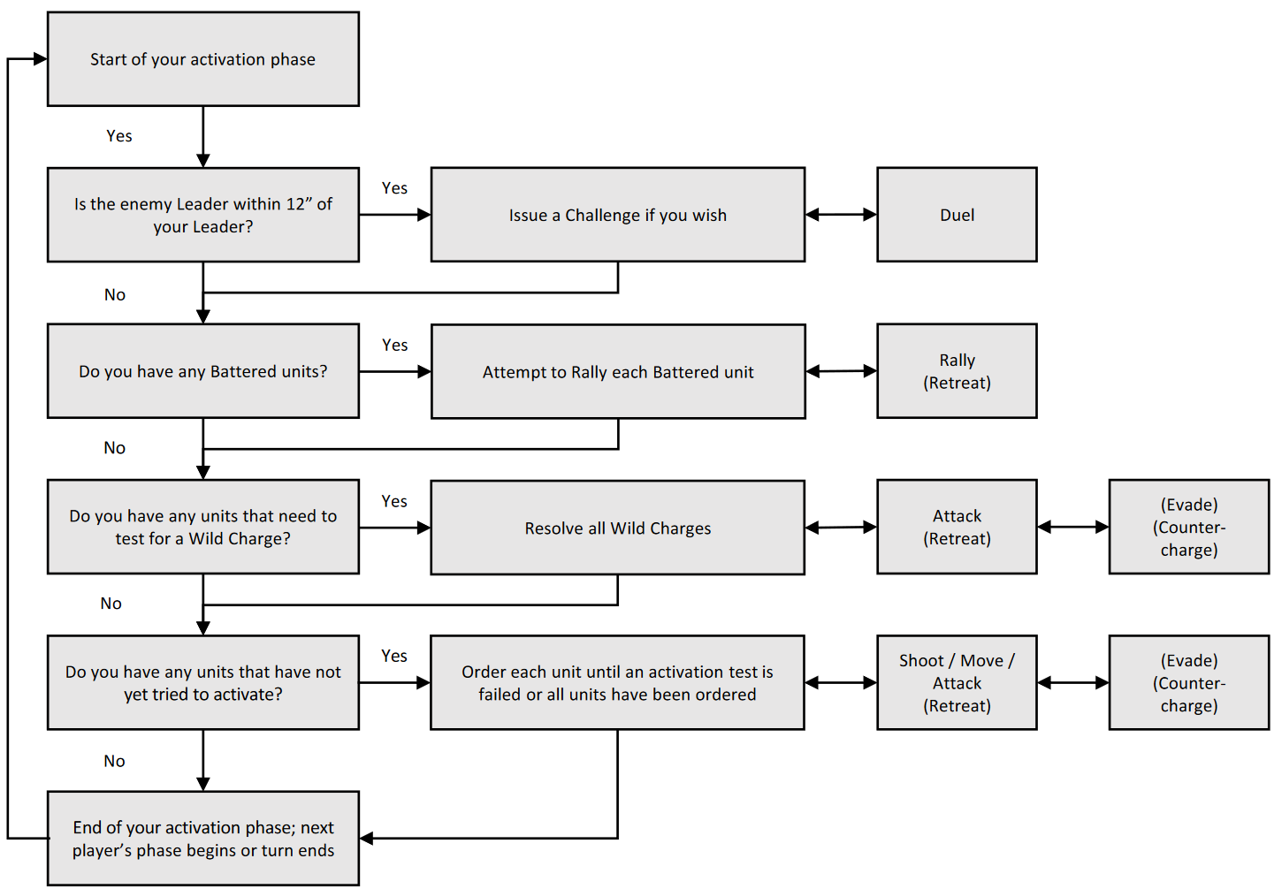
IN YOUR ACTIVATION PHASE
- Issue a Challenge.
- Rally Battered units.
- Activate Wild Charges.
- Order activations.
LEADERS
- Last Model to die unless falling to a Lucky Blow or Challenge.
- Each turn, your may reroll one failed Move, Attack, or Shoot test (no other tests) within 12” of your Leader’s model unless Leader is Battered. This may be applied to the Leader’s own unit.
- +1 to your total for all Courage tests within 12” of your Leader model (including the Leader’s unit) unless Leader is Battered.
- Leaders may issue Challenges.
RALLYING
- Successful: remove Battered marker; cannot activate during this activation phase.
- Unsuccessful: retain Battered marker, remove 1 model, Retreat; take no further action during this activation phase. Disadvantaged if Attacked.
- Final score is 0 or negative, unit routs. Remove it immediately.
- Failed Rally activations do not end your activation phase.
SHOOTING RANGES
- Bows and crossbows: 18”
- Skirmishers, Mounted bows and crossbows: 12”
- Javelins: 6”
ATTACKING/SHOOTING
- 12 dice if above half strength (7 or 4 models).
- 6 dice if half strength or less (6 or 3 models).
- -1 to Shooting over 12”.
- Cover increases Armour by 1.
- Lucky Blows: Roll a double 1 on 2 D6.
- Battered units only hit on 6.
- Units in rough terrain: Attack and Defence of 5+; Armour of 2; unless Flexible.
WHEN TO TEST COURAGE
- The unit has taken casualties from Attacking or Shooting.
- The unit is attempting to Rally to remove a Battered marker.
- The unit becomes your only unit remaining on the table.
- Your Leader is killed or flees the table.
- Your Leader refuses a Challenge.
- The total value of your units in play drops to or below half your Warband’s full points value.
COURAGE TEST
- -1 per casualty the unit has suffered in the game.
- -1 if the points value of your units in play is half or less than the full points value of your warband.
- +1 to your total if your Leader’s model is within 12” (incl. the Leader’s unit) unless Leader is Battered.
FAILED COURAGE TEST
- Result > 0: unit must Retreat half move, becomes Battered.
- Result = 0: unit routs. Remove it immediately.
- A Battered unit which receives another Battered result loses 1 model and Retreats.

